Session 15

Assignment 2 Questions

*Session 15: Assignment 2*

**Table of Contents**

1. Introduction

2. Problem Statement

3. Output

**1. Introduction**

This assignment will help you to consolidate the concepts learnt in the session.

**2. Problem Statement**

3.Write a partial function to add three numbers in which one number is constant and two

numbers can be passed as inputs and define another method which can take the partial

function as input and squares the result.

4.Write a program to print the prices of 4 courses of Acadgild: Android-12999,Big Data

Development-17999,Big Data Development-17999,Spark-19999 using match and add a

default condition if the user enters any other course.

**3. Output**

Code and Output screenshot(s).

Write a partial function to add three numbers in which one number is constant and two

numbers can be passed as inputs and define another method which can take the partial

function as input and squares the result.

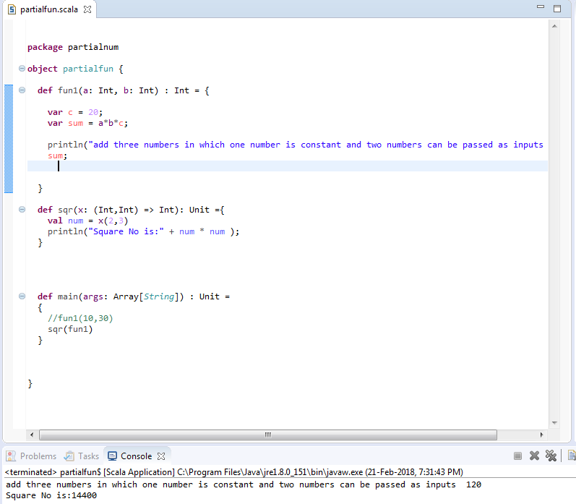

Write a program to print the prices of 4 courses of Acadgild: Android-12999,Big Data

Development-17999,Big Data Development-17999,Spark-19999 using match and add a

default condition if the user enters any other course.

